Distributed Computing 2024

T00212001

Author: Cillian Nolan

Munster Technological University

Lecturer: Peter Given

Table of Contents

Protocol Design 5

SMP (Short Message Protocol) Description: 5

Message Format Description: 5

Pseudo Code: 6

Carrying Out Inter-Process Communication: 9

Protocol Specification: 10

Sequence Diagram: 12

UML Diagram for GUI and CLI: 13

Software Architecture and Implementation 15

Application Layer: 15

Presentation Layer: 15

Service Layer: 15

Execute the functionality requested by user (CLI): 16

Host Connection and Login: 16

Send Message: 17

Retrieve Message: 18

Retrieve All Messages: 19

Log out: 20

Execute the functionality requested by user (GUI): 22

Host Connection and Login: 22

Send Message: 24

Retrieve Message (GUI): 25

Retrieve All Messages (GUI): 26

Log Off (GUI): 27

Multiple User Access (GUI and CLI): 28

SSL and TLS: 30

Instructions to run 31

Terminal Method: 31

IntelliJ Method (Easiest way): 32

Appendices 33

Client: 33

secureSMPClientCLI: 33

secureSMPClientGUI: 36

Server: 41

secureSMPServer: 41

Handler: 44

connectionHandler: 44

connectionHandlerCLI: 45

References 48

# Protocol Design

### SMP (Short Message Protocol) Description:

Short Message Protocol (SMP) is a protocol that was design for secure, concurrent client-server communication, using TCP. SMP allows users to login, upload messages to the server, as well as download messages and log off. The protocol emphasizes secure transmission by using TLS/SSL for encryption. The protocol works over a request – response model where the client intiates requests, and the server sends back responses. The connection starts with a handshake to agree on encryption, followed by authentication, message exchange, and ends with a termination sequence.

### Message Format Description:

**Login:**

* **Message Format:** ‘[Username] [Password]’
* Takes a username and a password.

**Send Message:**

* **Message Format:** ‘[Message]’
* Takes just a message string value, can be anything e.g. ‘Hello World 1234!’

**Retrieve Message(s):**

* **Message Format:** ‘[Message_Number]’
* Takes the value of the selected message and returns it. E.g. If message number 5 is chosen, it will go through the messages saved, and return the 5th.

### Pseudo Code:

To make a mock up of the pseudocode, I did it by hand as I find typing pseudocode to be trickier and messier than being able to write it by hand.

**Login:**

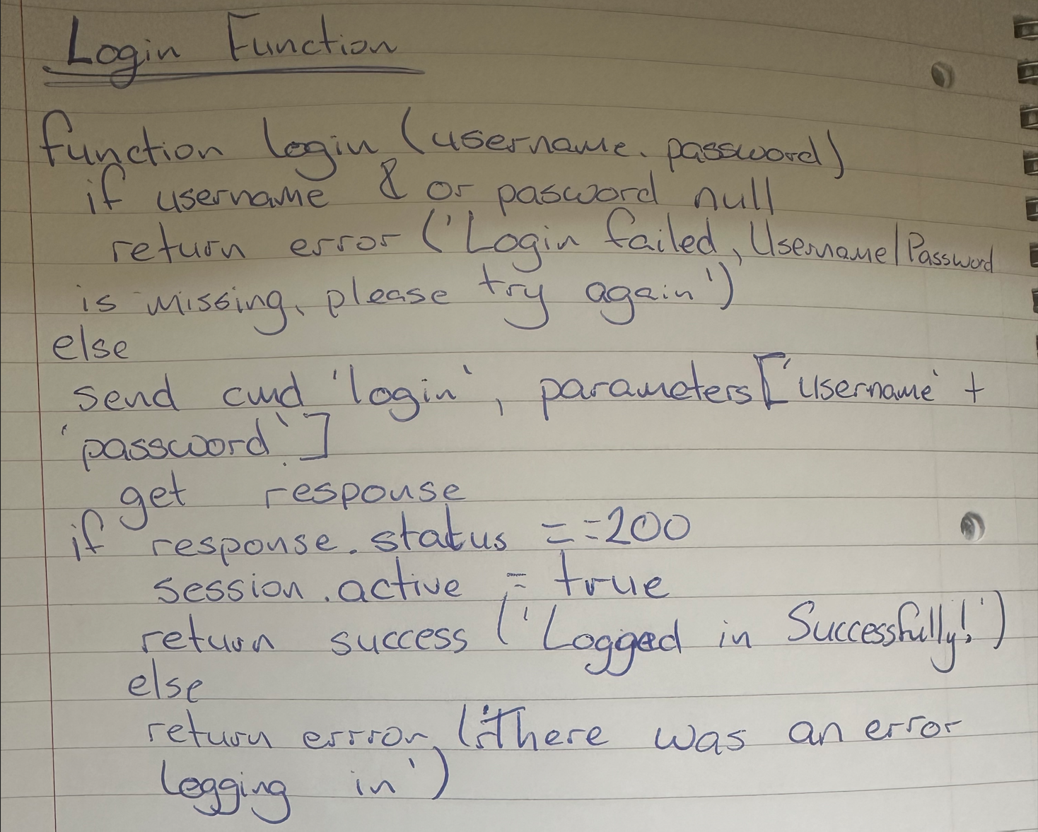

**Send Message:**

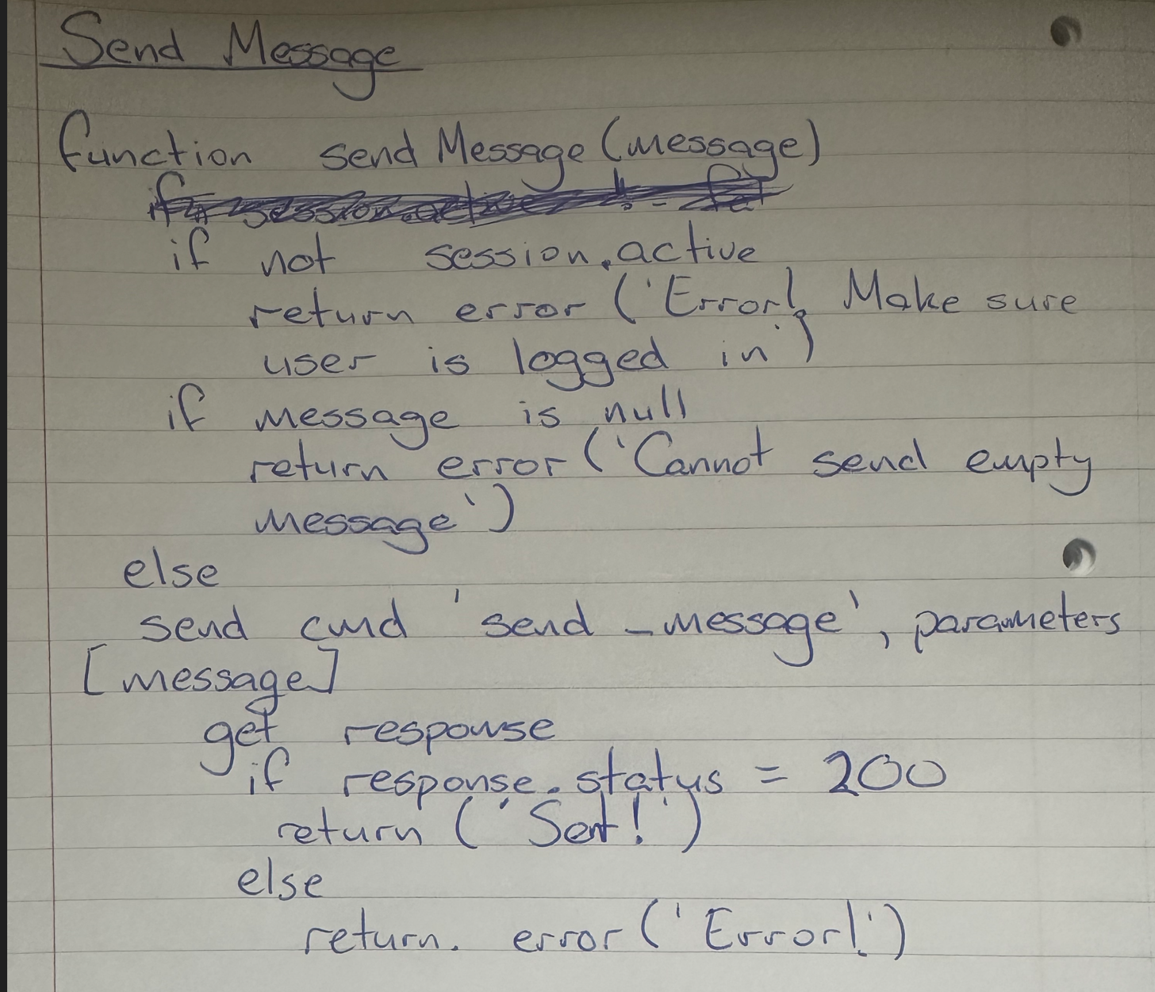

**Retrieve Message:**

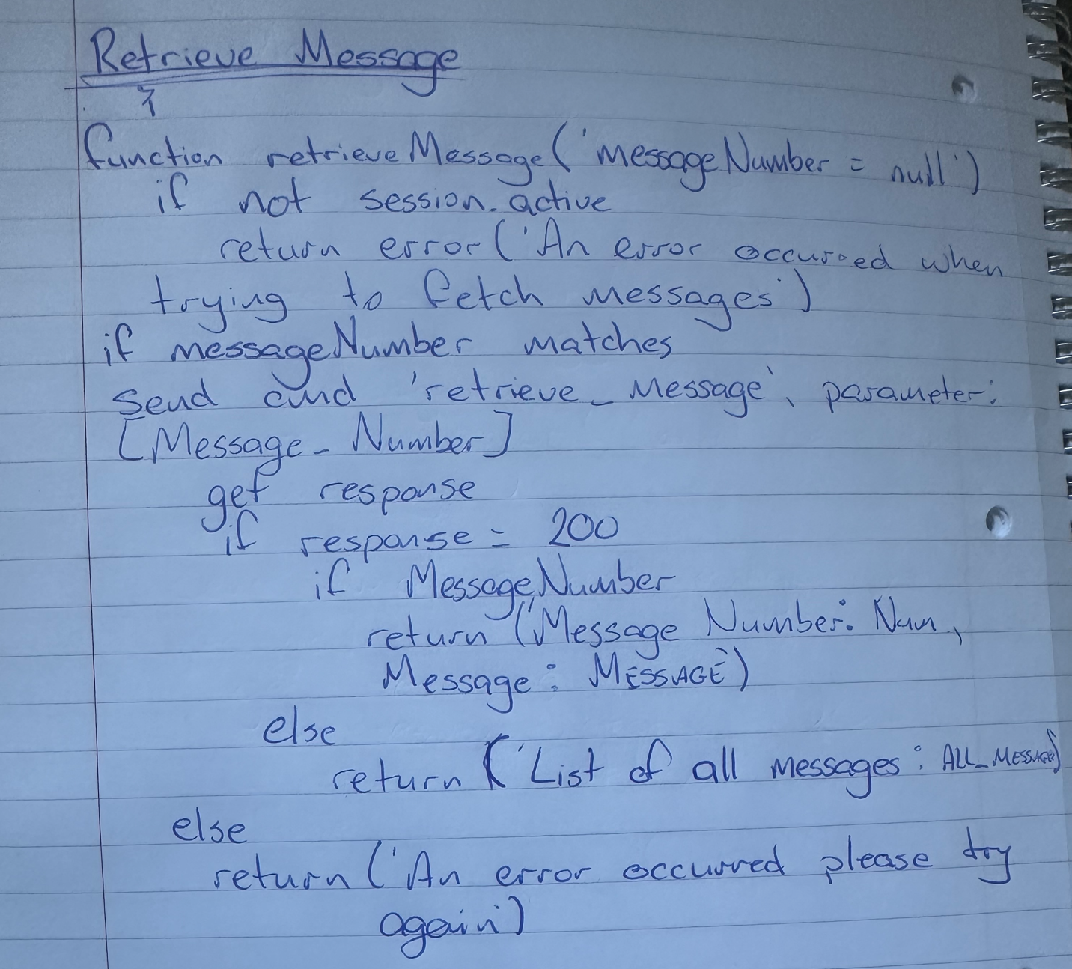

**Logout:**

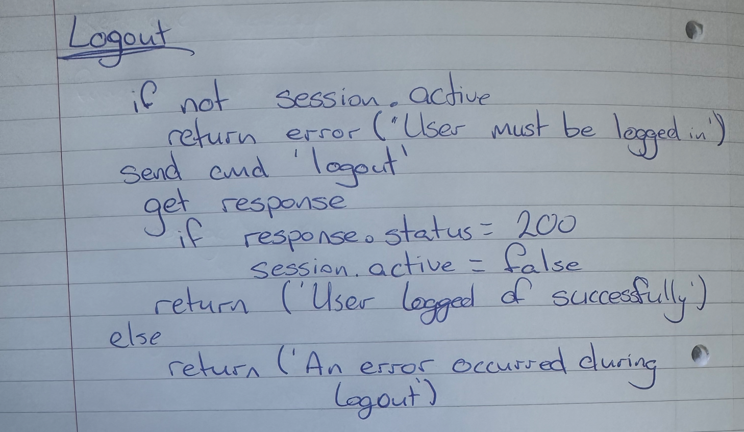

### Carrying Out Inter-Process Communication:

Inter-process communication is fundamental to the operation of SMP, as itt facilitates the exchange of short messages between the client and the server over a network.

Establish TCP Connections: TCP has to be used for a reliable and ordered delivery of bytes between the client and server. This is done by setting up a server that will listen on a specified port, while clients connect to that server.

Secure data with TLS/SSL: TCP Connections should be wrapped to encrypt the communication for security and confidentiality.

Use request/response model: Use a request/response model where clients sent requests to the server, such as this project, to receive responses based on requests.

Manage sessions: With handshakes for encryption, authenticate clients and maintain sessions states for secure messaging.

Implement message passing by using standardized formats for each action, allowing structured and understandable communication.

Support constant access by designing the server to handle multiple client connections at once. This can be achieved by using multithreading.

Include error handling to address and issues that may arise during use, such as showing parameter errors etc.

## Protocol Specification:

#### Login Request:

To initiate a session, a login request must be sent, which will include a username and a password within the message body.

* **Command:** ‘login’
* **Message Format:** ‘[Username] [Password]’

**Responses:**

* **If successful:** Status Code: 200, Command:‘server_response’, Response Message: ‘Logged in successfully!’
* **If Missing Parameter(s):** Status Code: 400, Command: ‘server_response’, Response Message: ‘Login Failed, Username/Password is missing, please try again’
* **Other Failure:** Status Code: 400, Command: ‘server_response’, Response Message: ‘There was an error logging in, ttry again later’.

#### Send Message:

A send message request will allow a logged in user to send and save a message to the server.

* **Command:** ‘send_message’
* **Message Format:** ‘[Message]’

**Responses:**

* **If successful:** Status Code: 200, Command:‘server_response’, Response Message: ‘Sent!’
* **If Missing Parameter:** Status Code: 400, Command: ‘server_response’, Response Message: ‘Cant send an empty message.’

#### Retrieve Message(s):

A send message request will allow a logged in user to send and save a message to the server.

* **Command:** ‘retrieve_message’
* **Message Format:** ‘[Message_Number]’

**Responses:**

* **All Messages:** Status Code: 200, Command:‘server_response’, Response Message: ‘List of all messages: ALL_MESSAGES’
* **If user chooses a singular message:** Status Code: 200, Command: ‘server_response’, Message: ‘Message Number: NUMBER \nMessage: MESSAGE’
* **If error:** Status Code: 400, Command ‘server_response’, Response Message: ‘An error occurred when trying to fetch message(s). Please try again’.

#### Logout Request:

The logout request will end the session, it requires a user to be logged in to work.

* **Command:** ‘logout’

**Responses:**

* **Success:** Status Code: 200, Command:‘server_response’, Response Message: ‘User logged off successfully. Thanks for using the messaging system.’

## Sequence Diagram:

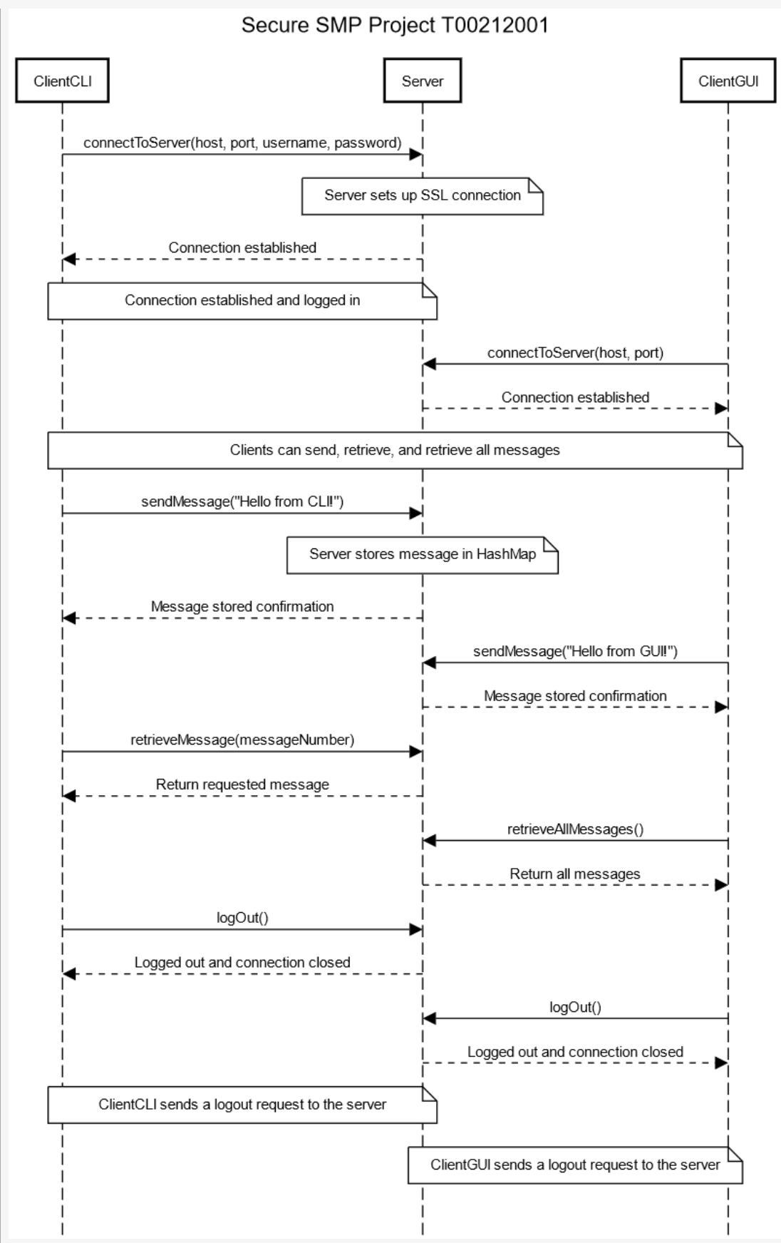

Figure - Made using 'sequencediagram.org'

## UML Diagram for GUI and CLI:

Below is a UML diagram generated in IntelliJ showing Server, and CLI and GUI classes.

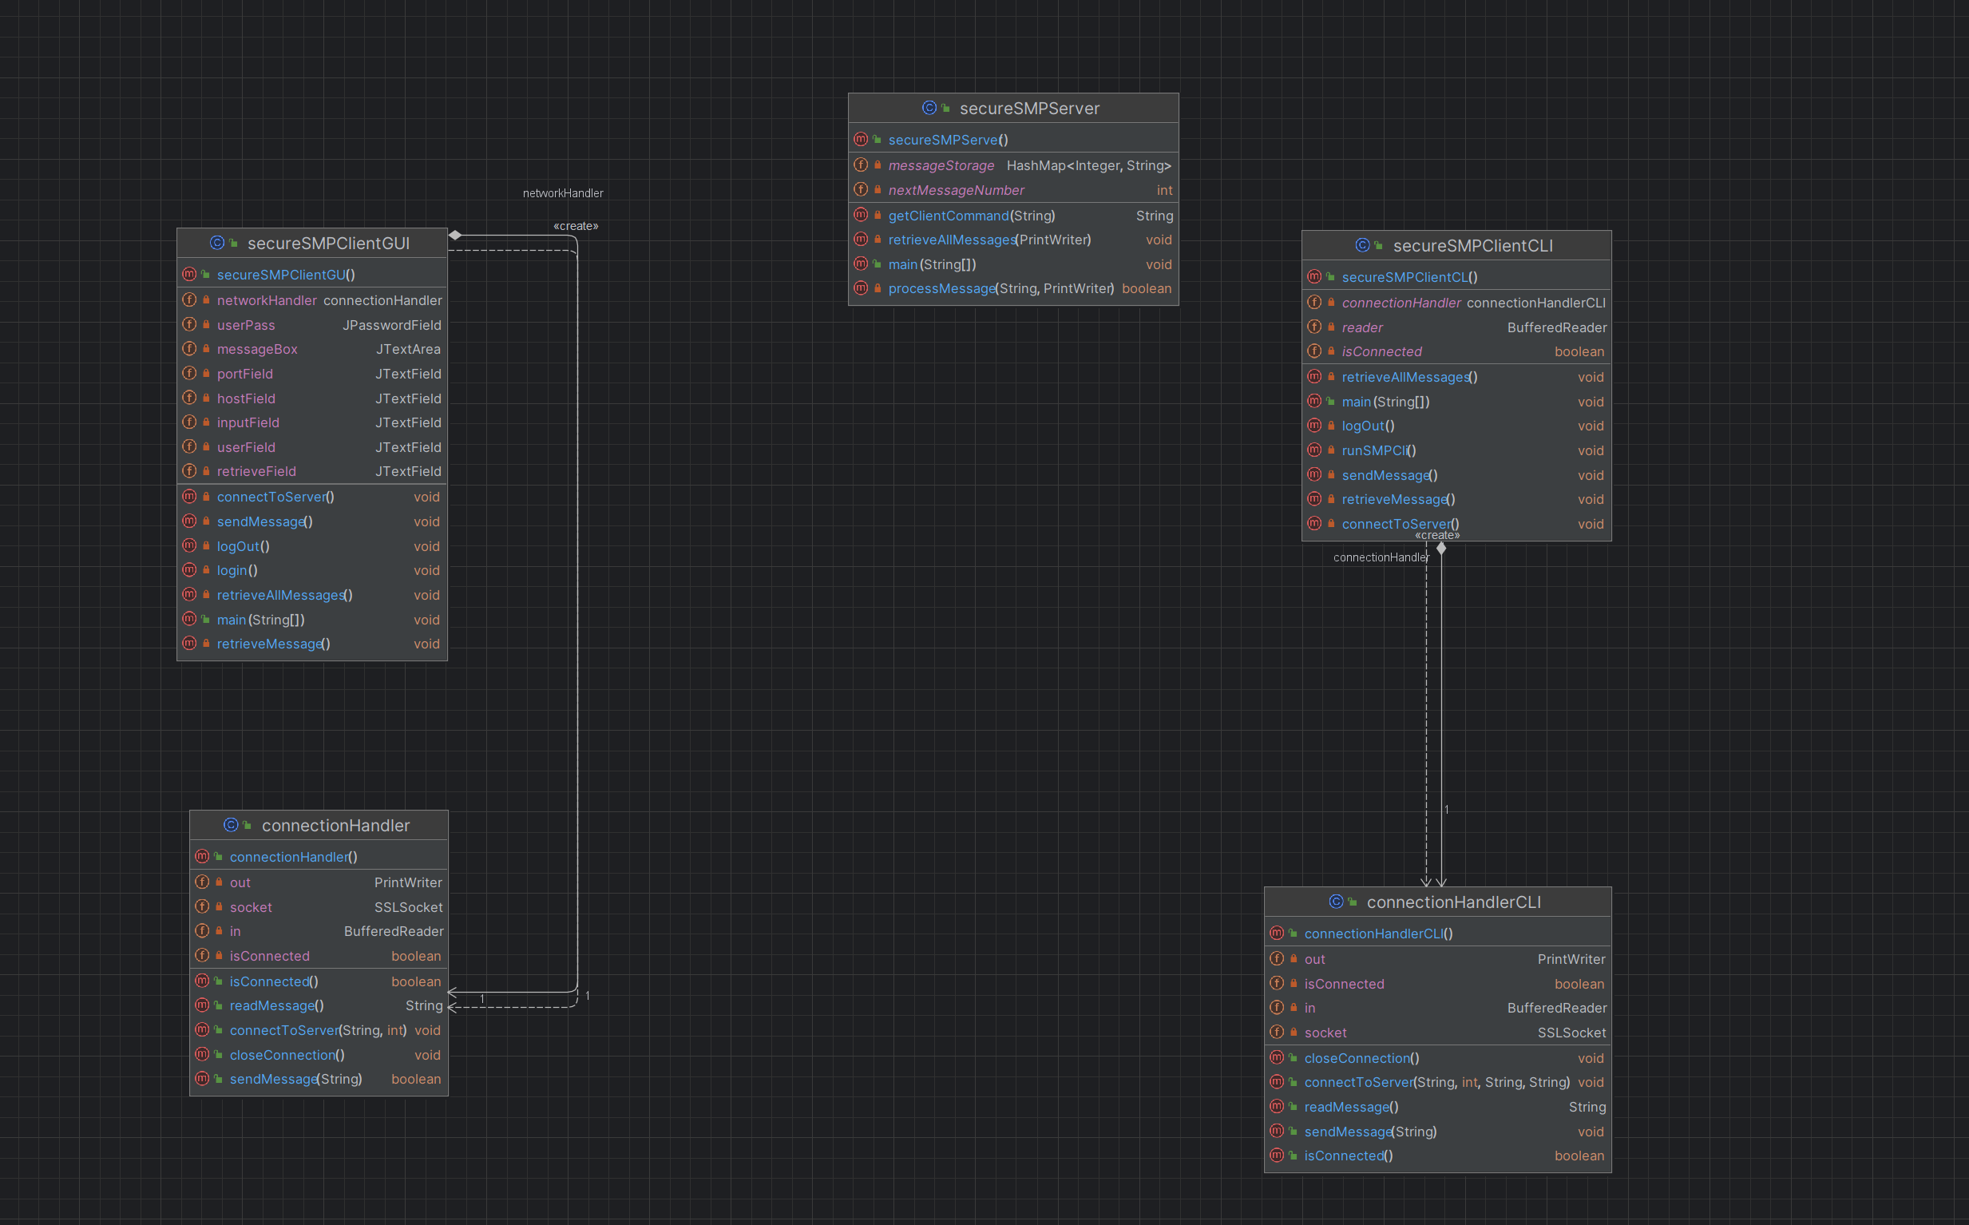

Figure - UML Generated in IntelliJ

# Software Architecture and Implementation

## Application Layer:

In SMP, the application layer has an important role in enabling secure, and encrypted communication between clients on the server. This is the layer where the core functionalities of SMP, such as sending messages, retrieving a message or messages, and user authentication are enabled. It essentially enables secure communication while simplifying the use of underlying network protocols and encryption mechanisms.

## Presentation Layer:

In SMP, the Presentation Layer's responsibilities, such as encryption, data formatting, and interface representation, are integrated within the application. It utilizes SSL/TLS for encryption and ensures data is appropriately formatted for transmission. The user interfaces, CLI and GUI, present data in an accessible manner, facilitating intuitive user interactions.

## Service Layer:

The Service Layer in SMP abstracts the core message handling logic, including sending, retrieving, and authenticating messages, away from the user interfaces. It acts as the intermediary between the interfaces (CLI/GUI) and the server, encapsulating the ‘business logic’ and ensuring modular and scalable communication services. This layer makes the process of secure communication transparent and efficient for users.

## Execute the functionality requested by user (CLI):

To implement the functionality requested by the user a command line interface version was created. This utilizes a host and port connection choice, a username and password login, and then options between sending a message, retrieving a specific message (based on a number) and retrieving all messages.

The server side of this will show ‘logs’ of what is being done, as well as status codes, indicating whether certain requests are being fulfilled as requested.

For the sake of this project, take the host as ‘localhost’ and the port as ‘8989’.

### Host Connection and Login:

The command line interface SMP client allows the user to select a Host, and Port to connect to. For this project, ‘localhost’ and port ‘8989’ were used. It uses the method connectToServer() to try and establish a connection between the client and server using SSL. The server also asks for a username and password to enable the login to work.

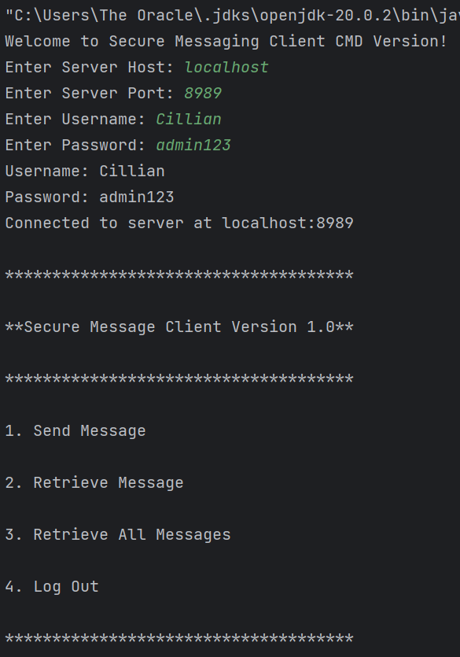 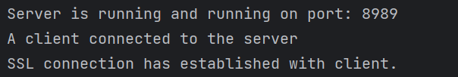

Figure - Client CLI Connection Figure – Server Interface

### Send Message:

The command line interface SMP client also facilitates a function to the user that allows the sending of a message to the server. This is done by using the sendMessage method, which also makes use of the ‘upload_message’ command. If a message is successfully sent, the user will be notified with a message saying *‘Message sent successfully!’.* On the server side, provided that the message is sent, it will show the message received from the client and a success message will show, along with the status code, and command used.

A HashMap is used to store the messages in memory while the server is being ran.

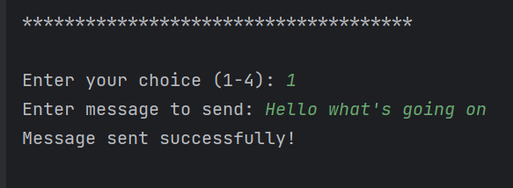

Figure - Client CLI Interface Send Message

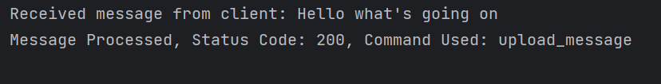

Figure - Server Side Interface Message Received

### Retrieve Message:

The server also allows a user(s) to retrieve a message from the server. This will only work is a message(s) is stored on the server, otherwise it will throw an error saying an error. Messages are numbered +1 as they are sent. i.e. if you want to receive the second message simply put in message ‘2’ to receive it.

The user will select the retrieve message option, and put in the message they want to receive. This will use the ‘retrieve_message’ command and return the message, provided it exists.

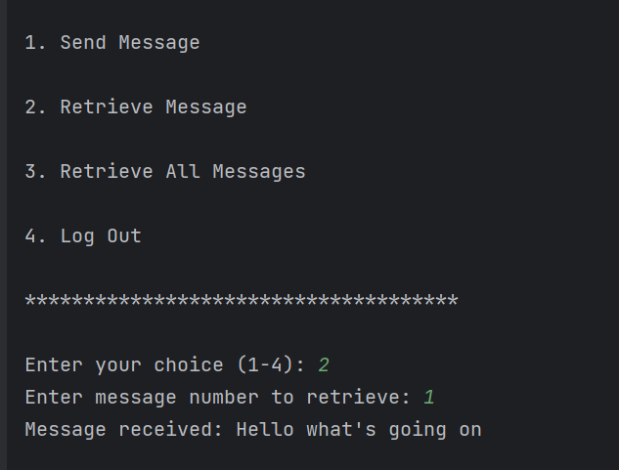

Figure - Retrieve Message '1'

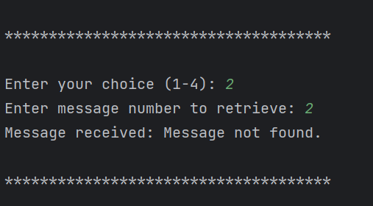

Figure - Attempt to retrieve non existing message

### Retrieve All Messages:

This works in the same way as retrieve message, except it will retrieve all messages if the user selects the option, provided messages exist.

To show this working, the server was restarted so no messages would exist, and the user tried to retrieve all messages. An error was shown.

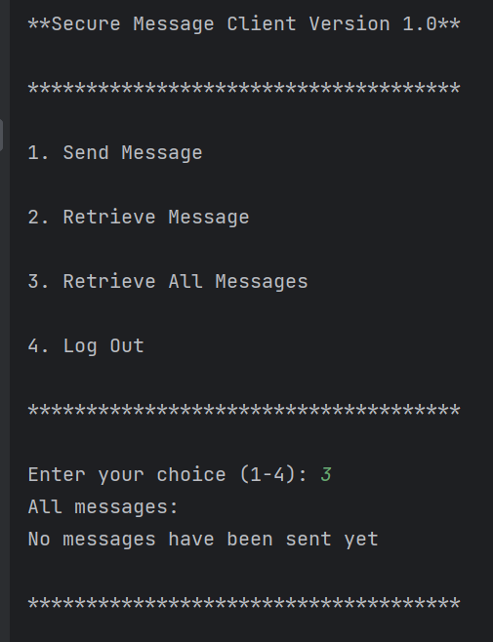

Figure - Retrieving all messages with none existing

On the server side, a status 200 code is shown to show that the command executed successfully.

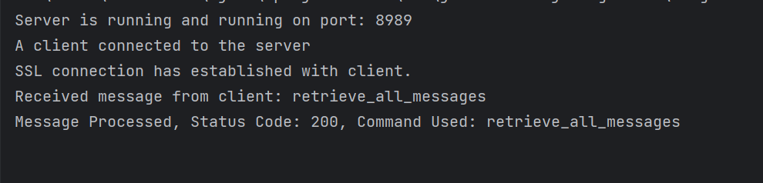

Figure - Retrieve all messages

To show it working retrieving messages that are stored, three messages were sent to the server.

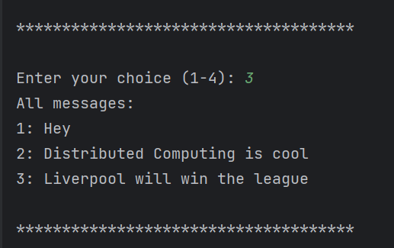

Figure - Retrieving messages

### Log out:

Lastly, users are able to log out by selecting the log out option. Once the user is logged in they will be allowed to select the log out command. This uses the logout method which sends the ‘logout’ command to the server. This will close the connection between the client and server and disconnects the user from it. It will show a message on the client saying *‘Logged out and disconnected from server’* and the server will show *‘Client has logged off. Bye bye client’*.

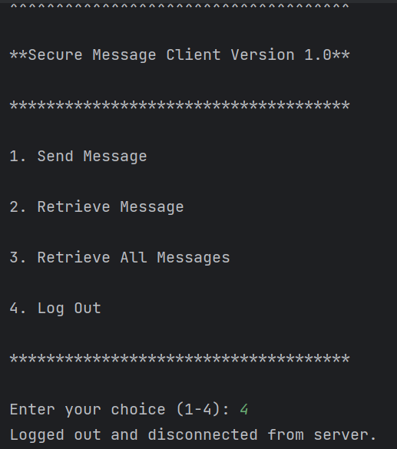

Figure - Client Log Out

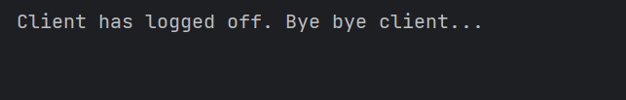

Figure - Server gets client logout message

## Execute the functionality requested by user (GUI):

Another version with the same functionality was created, that incorporated a GUI made using JPane. This version is an easier and more seamless version which allows a connection to be made to the server, with a login, as well as the ability to send and receive messages. The GUI also incorporatd buttons to facilitate the use of commands being sent to the server in an easier manner. It also has error handling and some validation in place so that certain things can’t be done to ‘break’ the application.

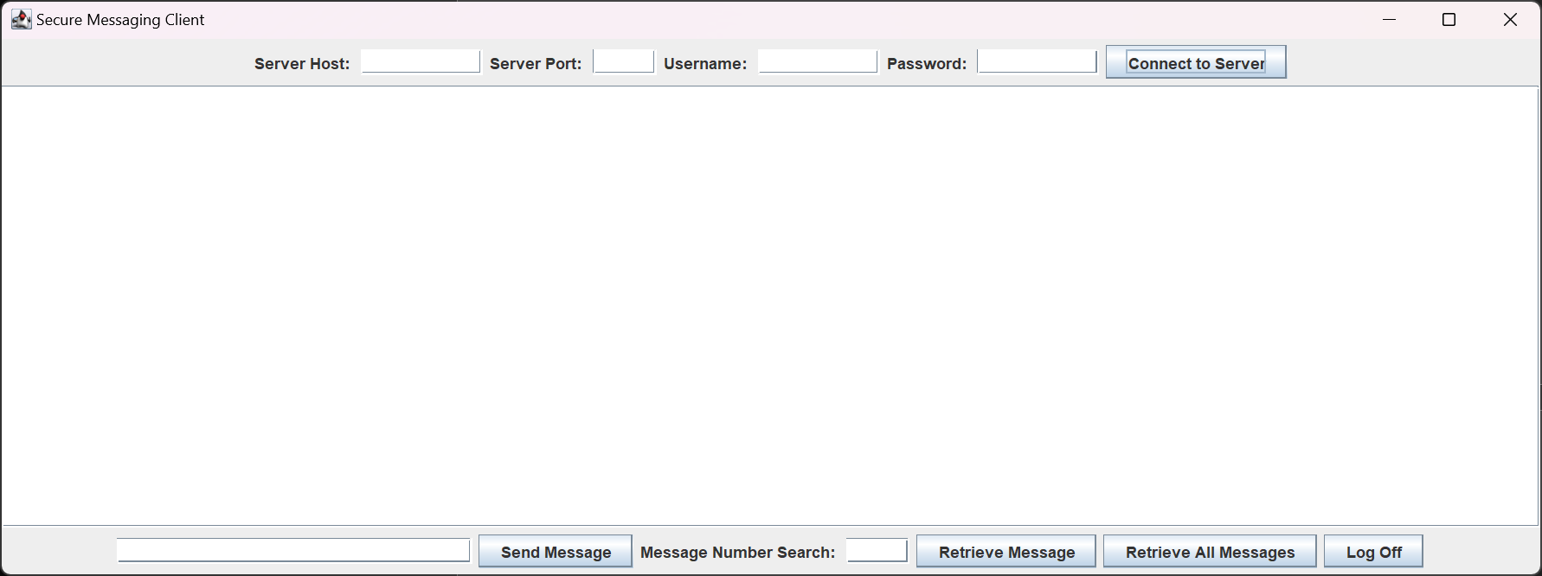

Figure - GUI of SMP Client

### Host Connection and Login:

Similar to the CLI, the user will be able to enter a host, port, username and password. If a user attempts to send a message, retrieve a message, or retrieve all messages before connecting to the server, errors will be given. If a user attempts to log off without connecting, the application will simply shut instead.

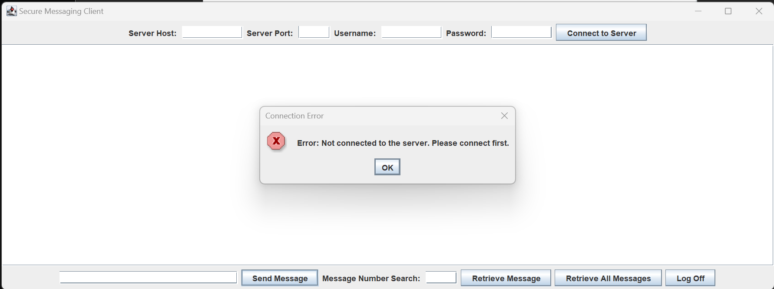

Figure - Attempt to send message without connection

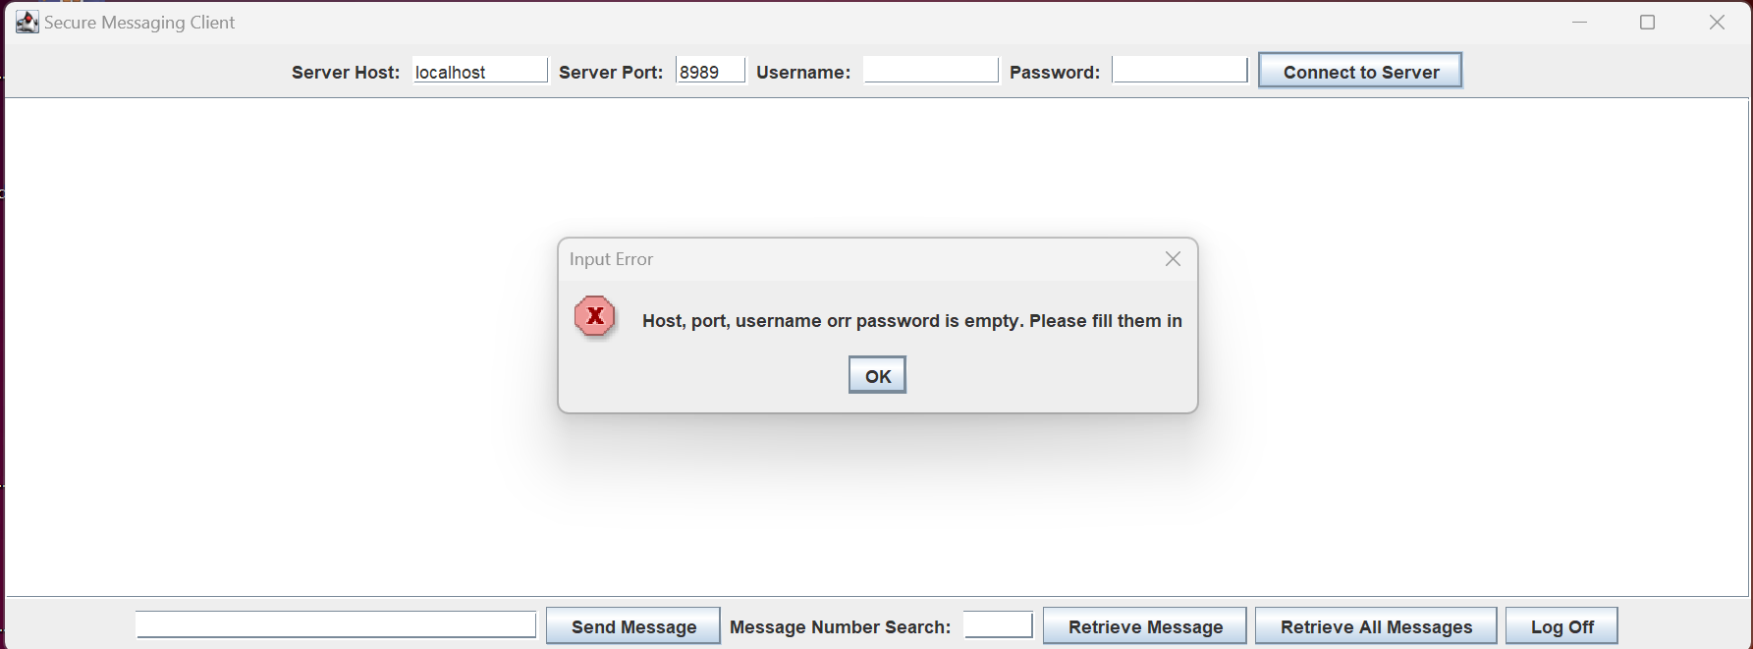

Figure - GUI Connecting to Server with Username/Password

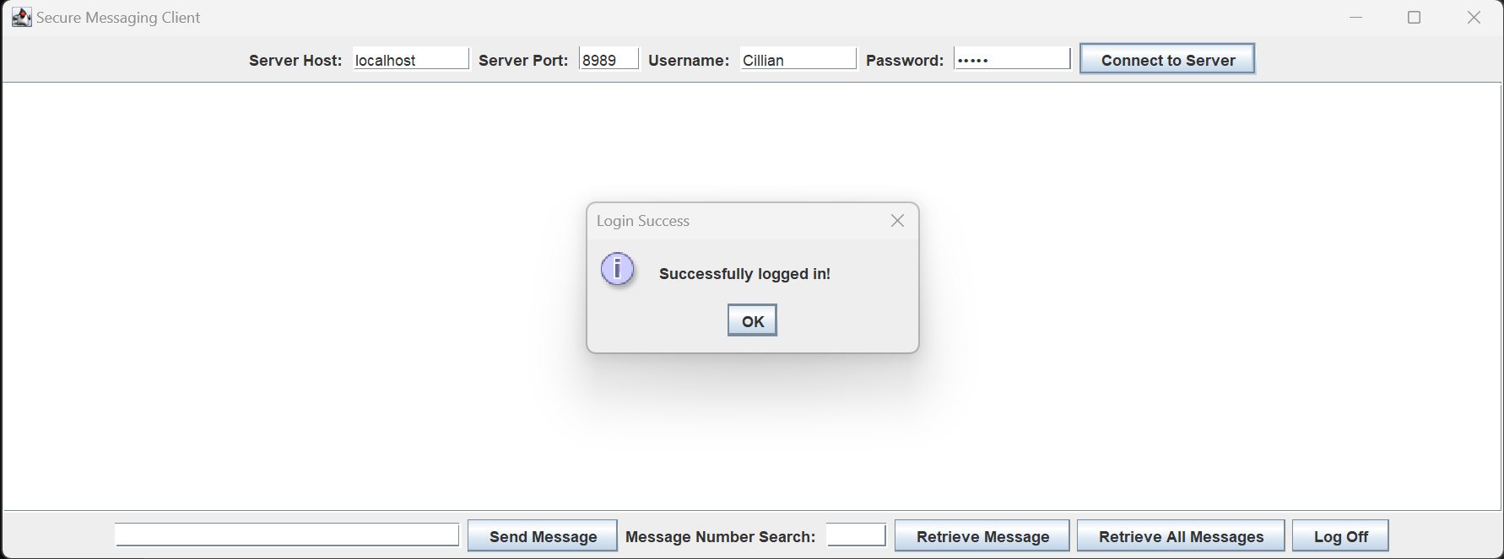

Figure - Successful connection/login

Once the user connects and logs in, the server gets a response that the connection has been successful.

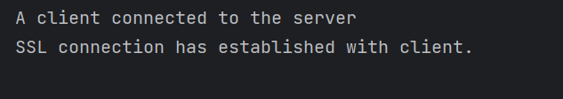

Figure - User Connection Success GUI

### Send Message:

For the user to send a message they must first of all be connected to the Host, and logged in. They can then type into the message box any message that they wish to send. When a message is sent in the GUI, a confirmation will show in the message box, and show the ‘Message Number’ associated with it. It uses the sendMessage command in order to send it, and uses a ‘nextMessageNumber’ integer to add +1 to each message sent.

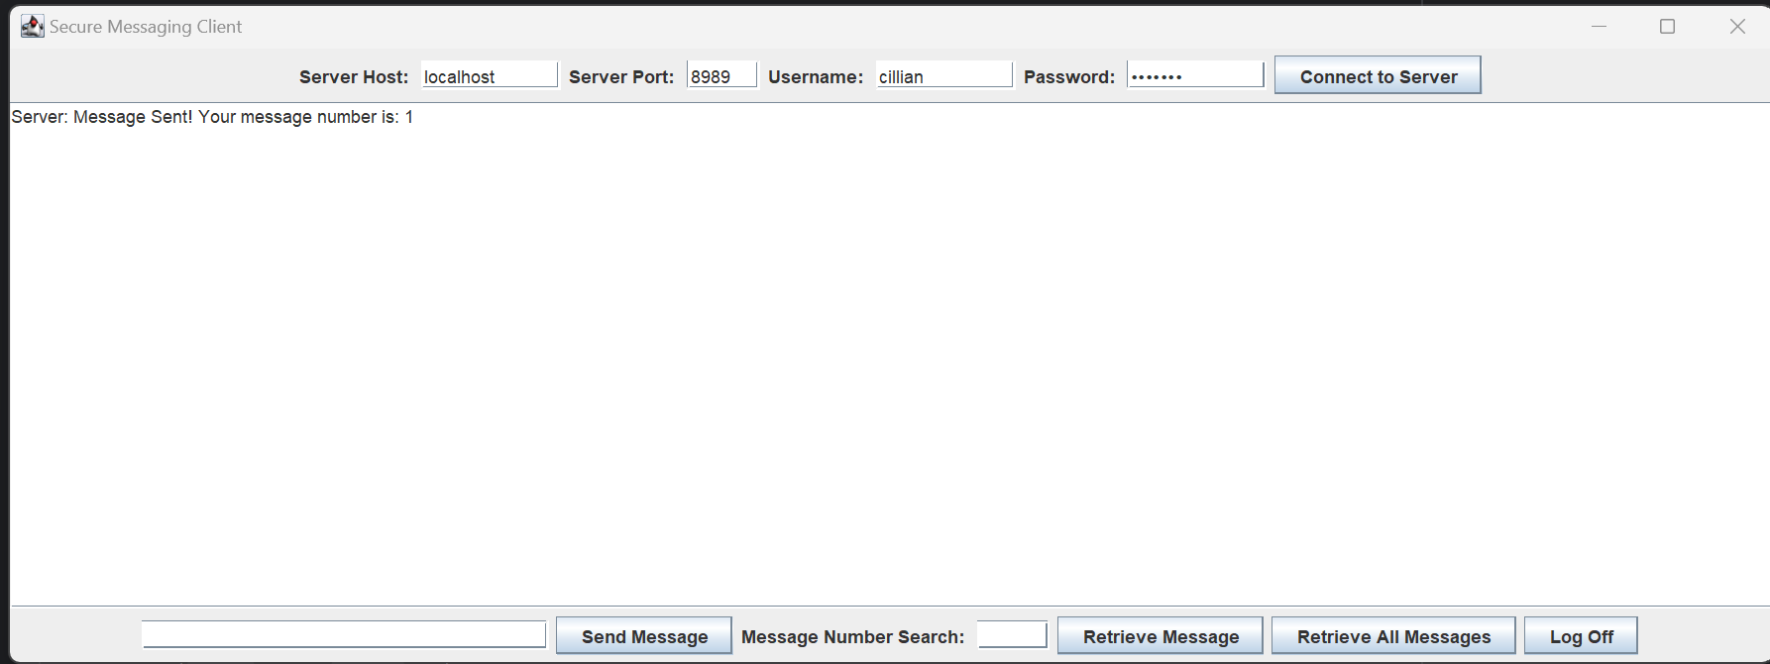

Figure - Message Sent GUI

On the server side, for confirmation that the message is received, it shows the following:  
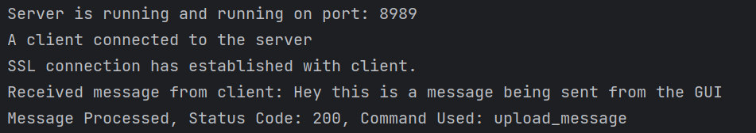

Figure - Server GUI Send Message Confirm

### Retrieve Message (GUI):

The user may also retrieve messages using the GUI. This will only work if a message(s) is stored on the server, otherwise it will show an error. To do this the user will have to type into the Message Number Search box, and look for the number message that they want, and then select the ‘Retrieve Message’ button. This will then search for a message based on the number given by using the command ‘retrieve_message’ and ‘Number’. If a message is found, it will return in the message box, if not, a message will show saying it doesn’t exist.

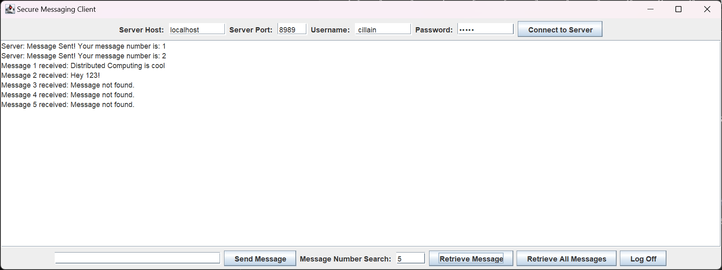

Figure - Retrieve Message GUI

On the server side, confirmation is shown again, with status code and the command used

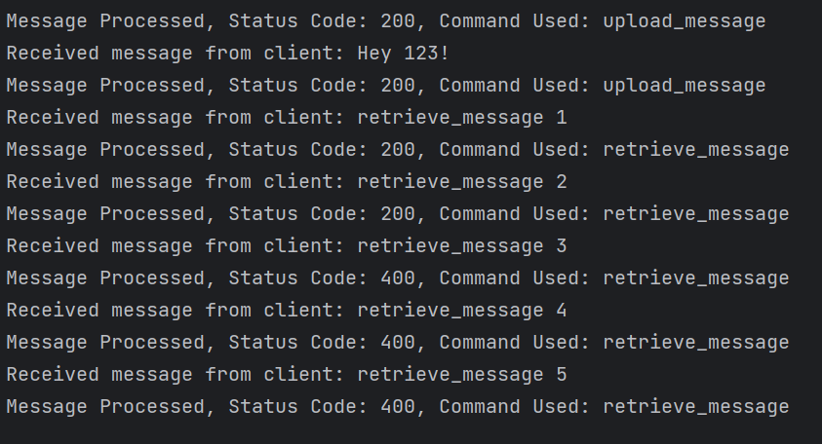

Figure - Server Retrieve Message GUI

### Retrieve All Messages (GUI):

The user may retrieve all messages sent to the server using the GUI. This again will only work if a message(s) is stored on the server, otherwise it will throw an error saying an error. To do this the user the user only has to click the Retrieve All Messages button, and it will call the ‘retrieve_all_messages’ command, and if messages exist, will show in the message box.

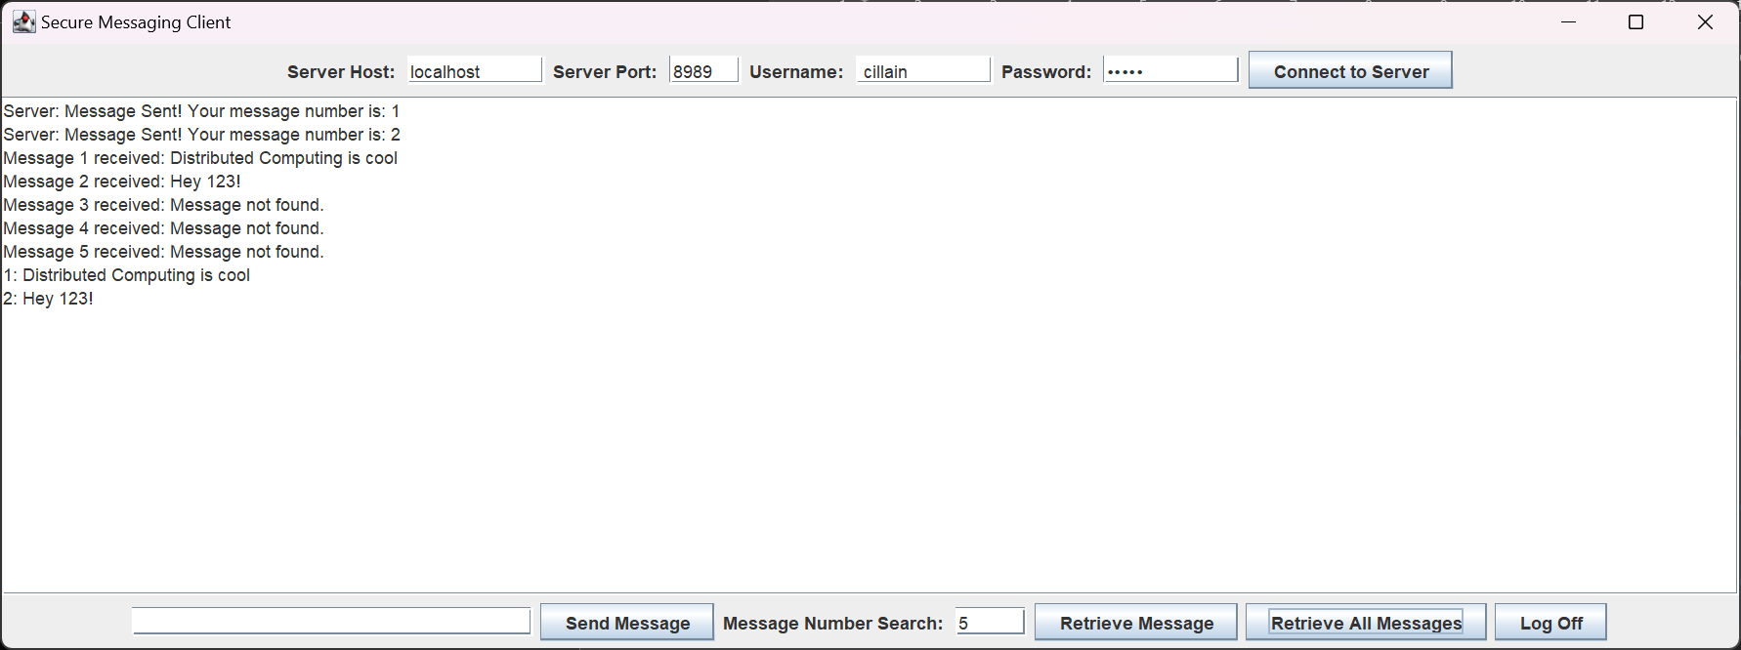

Figure - Retrieve All Messages GUI

### Log Off (GUI):

To log off from the server, the user can select the ‘Log off’ button, this will send the log out command to the server which will then close the connection between the client and the host.

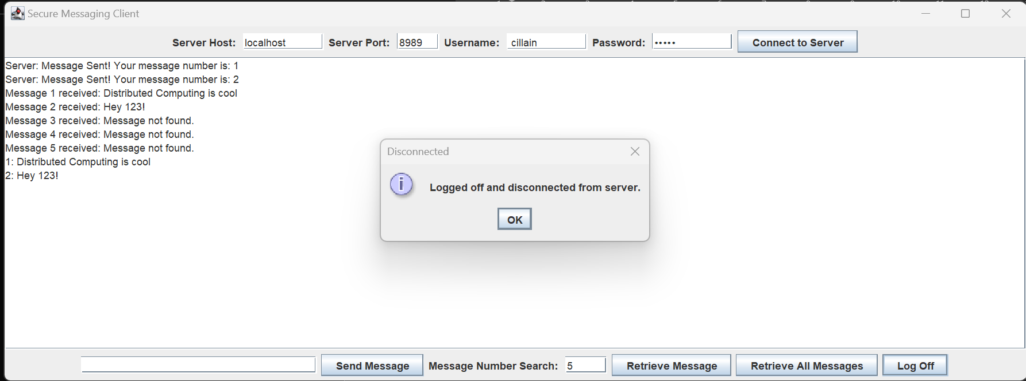

Figure - Log out GUI

## Multiple User Access (GUI and CLI):

To demonstrate that multiple users can connect to the server, below will show a GUI Client from my laptop running, and connecting to the server (hosted on my desktop) and it will show a GUI Client on my desktop, as well as a CLI Client on my desktop, all running at the same time.

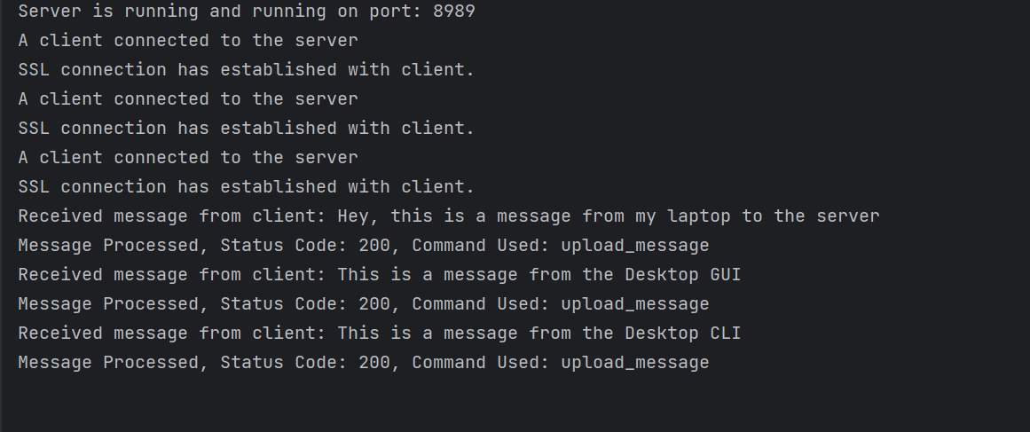

Figure - Server showing 3 connections

As we can see, 3 users are connected at the same time and communicating with the server. To showcase that message download works from both the laptop and desktop, I’ve retrieved all messages on both GUI’s and attached an image.

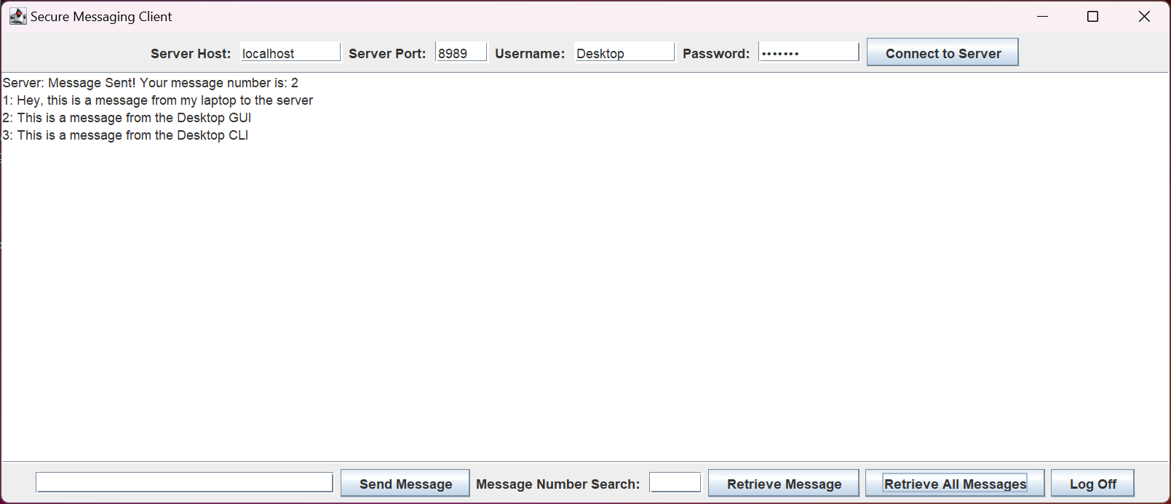

Figure - Multiple User Desktop GUI Retrieving Messages

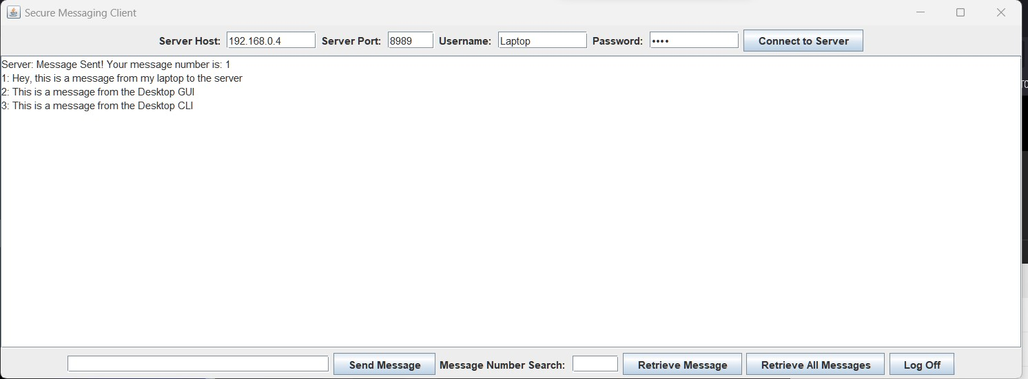

Figure - Laptop GUI Retrieving Messages

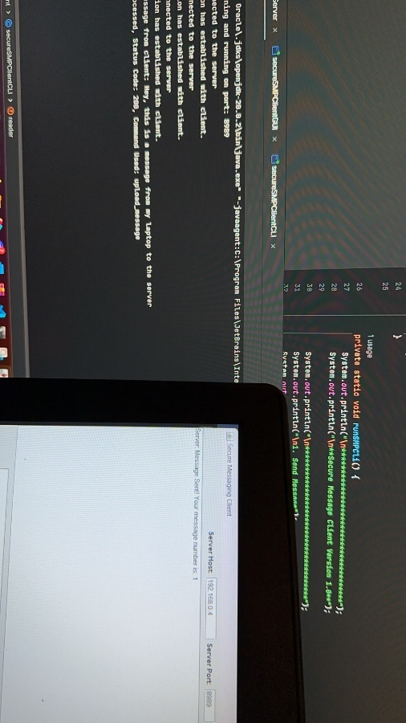

Figure - Message being sent from laptop to Desktop

Overall this proves that the server is able to have multiple users at the one time, uploading, and downloading messages from the server.

## SSL and TLS:

In this project, SSL and TLS encryption served as a fundamental security mechanism to facilitate secure communication between the client(s) and the server. SSL and TLS was used to encrypt data in transit so that all messages being sent, were sent securely. This was done by making use of the ‘SSLSocket’ and ‘SSLSocketFactory’ in the project. The encryption process starts with a ‘handshake’, which sets up the encryption parameters for the servers identity to be authenticated through digital certificates which were generated at the start of the project.

The implementations of SSL and TLS in this project shows that encryption ensures privacy and security of messages being sent and retrieved. The project handles the certificates and keys through a ‘truststore’ and a ‘keystore’.

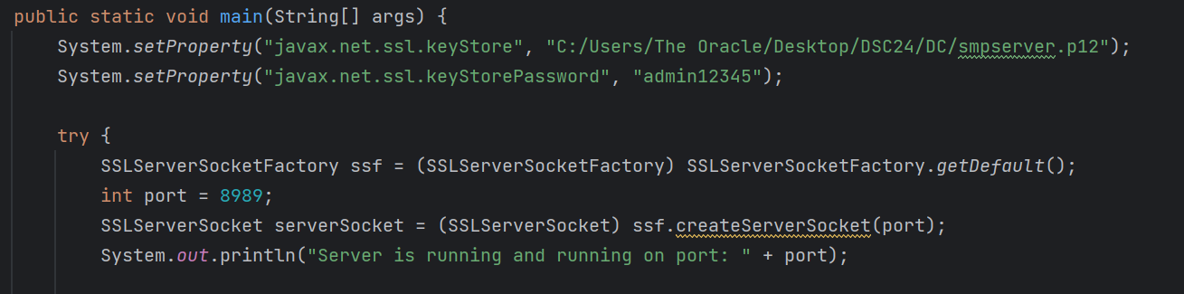

Figure - Sample of SSL

# Instructions to run

## Terminal Method:

When you download the code, ensure you’re in the main directory. E.g. C:\Users\YourComputerName\Downloads\MYCODEFOLDER

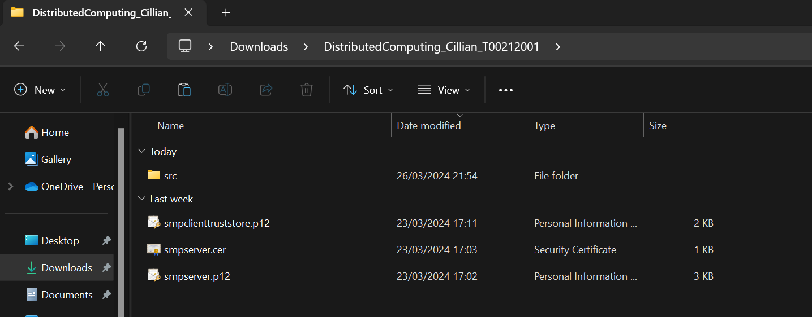

Figure - What you should see

From here, open the command terminal, you will need at least 2 opened. Copy and paste the below code to compile the .java files.

If you run into an error, ensure that in the secureSMPServer.java file, line 25, that the directory is set to the smpserver.p12 file as it relates to your machine.

The same will be done for line 22 in connectionHandlerCLI.java and line 21 in connectionHandler.java. *(I tried using dynamic file loading i.e. using “../../smpclienttruststore.p12 etc. but ran into difficulty, this was the easiest way across my machines to work it)*

From the main directory, run the following command:

*javac -cp src -d bin src/client/secureSMPClientCLI.java src/client/secureSMPClientGUI.java src/handler/connectionHandlerCLI.java src/handler/connectionHandler.java src/server/secureSMPServer.java*

This will compile the necessary .java files.

Next, using the first command window, CD to the server directory and run the following:  
*‘java secureSMPServer.java’*

Then, in another command window, CD to the client directory, here, you can decide whether to use the secureSMPClientGUI, or the secureSMPClientCLI.

*‘java secureSMPClientGUI.java’* OR *‘java secureSMPClientCLI.java’*

## IntelliJ Method (Easiest way):

1. Open project folder
2. Define JDK setup (I used OpenJDK 20, I think it might work with version 22 as well, I’m not entirely sure the version I had installed on my laptop when testing there)
3. Edit the secureSMPServer.java file, line 25, that the directory is set to the smpserver.p12 file as it relates to your machine. The same will be done for line 22 in connectionHandlerCLI.java and line 21 in connectionHandler.java.
4. In the secureSMPServer.java class, you can select Run in the top nav bar, and select run secureSMPServer.java, do the same for the secureSMPClient/secureSMPServer classes.

# Appendices

## Client:

### secureSMPClientCLI:

package client;  
  
import handler.connectionHandlerCLI;  
  
import java.io.BufferedReader;  
import java.io.IOException;  
import java.io.InputStreamReader;  
  
public class secureSMPClientCLI {  
 private static connectionHandlerCLI *connectionHandler* = new connectionHandlerCLI();  
 private static BufferedReader *reader* = new BufferedReader(new InputStreamReader(System.*in*));  
 private static boolean *isConnected* = false;  
  
 public static void main(String[] args) {  
 System.*out*.println("Welcome to Secure Messaging Client CMD Version!");  
  
 while (true) {  
 if (!*isConnected*) {  
 *connectToServer*();  
 } else {  
 *runSMPCli*();  
 }  
 }  
 }  
  
 //This code sets the CLI for the application, and allows the user to input a chice of what they wish to do.  
 private static void runSMPCli() {  
 System.*out*.println("\n*************************************");  
 System.*out*.println("\n**Secure Message Client Version 1.0**");  
  
 System.*out*.println("\n*************************************");  
 System.*out*.println("\n1. Send Message");  
 System.*out*.println("\n2. Retrieve Message");  
 System.*out*.println("\n3. Retrieve All Messages");  
 System.*out*.println("\n4. Log Out");  
 System.*out*.println("\n*************************************");  
  
 try {  
 System.*out*.print("\nEnter your choice (1-4): ");  
 String choice = *reader*.readLine();  
 switch (choice) {  
 case "1":  
 *sendMessage*();  
 break;  
 case "2":  
 *retrieveMessage*();  
 break;  
 case "3":  
 *retrieveAllMessages*();  
 break;  
 case "4":  
 *logOut*();  
 System.*exit*(0);  
 break;  
 default:  
 System.*out*.println("Invalid choice. Please enter a number from 1 to 4.");  
 }  
 } catch (IOException e) {  
 System.*err*.println("Error reading input: " + e.getMessage());  
 }  
 }  
  
  
 // This method asks the user for the host, port, a username and password also, it then uses the connectionHandler  
 // method connectToServer with those inputs to try establish a connection to the server, once successful, it says  
 // connected to the server, with the host and port, if an error happens, it shows what happened.  
 private static void connectToServer() {  
 try {  
 System.*out*.print("Enter Server Host: ");  
 String host = *reader*.readLine();  
 System.*out*.print("Enter Server Port: ");  
 int port = Integer.*parseInt*(*reader*.readLine());  
 System.*out*.print("Enter Username: ");  
 String username = *reader*.readLine();  
 System.*out*.print("Enter Password: ");  
 String password = *reader*.readLine();  
 *connectionHandler*.connectToServer(host, port, username, password);  
 *isConnected* = true;  
 System.*out*.println("Connected to server at " + host + ":" + port);  
 } catch (IOException e) {  
 System.*err*.println("Error connecting to server: " + e.getMessage());  
 }  
 }  
  
  
 // This method allows the user to send a message to the server. It uses the connectionHandler class again  
 // to attempt to send the message, it shows a success or error message depending on the status of message being sent  
 private static void sendMessage() {  
 try {  
 System.*out*.print("Enter message to send: ");  
 String message = *reader*.readLine();  
 *connectionHandler*.sendMessage(message);  
 System.*out*.println("Message sent successfully!");  
 } catch (IOException e) {  
 System.*err*.println("Error sending message: " + e.getMessage());  
 }  
 }  
  
  
 // This method is used to try and retrieve a message from the server, it asks the user to input the  
 // 'number' of the message to be received. It works off the connectionHandler class to see if the message  
 // exists, and if it does, it will return the text of the message.  
 private static void retrieveMessage() {  
 try {  
 System.*out*.print("Enter message number to retrieve: ");  
 String msgNumber = *reader*.readLine();  
 *connectionHandler*.sendMessage("retrieve_message " + msgNumber);  
 String response = *connectionHandler*.readMessage();  
 System.*out*.println("Message received: " + response);  
 } catch (IOException e) {  
 System.*err*.println("Error retrieving message: " + e.getMessage());  
 }  
 }  
  
  
 // This method is used to try and retrieve all messages from the server, it uses the connectioNHandler class  
 // to go through all the messages stored, it loops through til it receives the 'end of messages' indicator.  
 // it simply prints the messages then onto the CLI  
 private static void retrieveAllMessages() {  
 try {  
 *connectionHandler*.sendMessage("retrieve_all_messages");  
 System.*out*.println("All messages:");  
 String response;  
 while (!(response = *connectionHandler*.readMessage()).equals("End of messages")) {  
 System.*out*.println(response);  
 }  
 } catch (IOException e) {  
 System.*err*.println("Error retrieving all messages: " + e.getMessage());  
 }  
 }  
  
  
 // This method simply sends the logout command to the server using the connectionHandler, and then closes the connection  
 private static void logOut() {  
 try {  
 *connectionHandler*.sendMessage("logout");  
 *connectionHandler*.closeConnection();  
 System.*out*.println("Logged out and disconnected from server.");  
 } catch (IOException e) {  
 System.*err*.println("Error during logging out: " + e.getMessage());  
 }  
 }  
}

### secureSMPClientGUI:

package client;  
  
import handler.connectionHandler;  
  
import javax.swing.*;  
import java.awt.*;  
import java.io.IOException;  
  
public class secureSMPClientGUI extends JFrame {  
 private final connectionHandler networkHandler = new connectionHandler();  
 private JTextArea messageBox;  
 private JTextField inputField;  
 private JTextField retrieveField;  
 private JTextField hostField;  
 private JTextField portField;  
 private JTextField userField;  
 private JPasswordField userPass;  
  
 public secureSMPClientGUI() {  
 setTitle("Secure Messaging Client");  
 setSize(1200, 450);  
 setDefaultCloseOperation(*EXIT_ON_CLOSE*);  
  
 messageBox = new JTextArea(10, 40);  
 messageBox.setEditable(false);  
 inputField = new JTextField(30);  
 retrieveField = new JTextField(5);  
 hostField = new JTextField(10);  
 portField = new JTextField(5);  
 userField = new JTextField(10);  
 userPass = new JPasswordField(10);  
  
 JButton connectButton = new JButton("Connect to Server");  
 JButton sendButton = new JButton("Send Message");  
 JButton retrieveButton = new JButton("Retrieve Message");  
 JButton retrieveAllButton = new JButton("Retrieve All Messages");  
 JButton logOutButton = new JButton("Log Off");  
  
 JPanel panel = new JPanel(new BorderLayout());  
  
 JPanel topLayout = new JPanel(new FlowLayout());  
 topLayout.add(new JLabel("Server Host: "));  
 topLayout.add(hostField);  
 topLayout.add(new JLabel("Server Port: "));  
 topLayout.add(portField);  
 topLayout.add(new JLabel("Username: "));  
 topLayout.add(userField);  
 topLayout.add(new JLabel("Password: "));  
 topLayout.add(userPass);  
 topLayout.add(connectButton);  
 panel.add(topLayout, BorderLayout.*NORTH*);  
  
 panel.add(new JScrollPane(messageBox), BorderLayout.*CENTER*);  
  
 JPanel bottomLayout = new JPanel(new FlowLayout());  
 bottomLayout.add(inputField);  
 bottomLayout.add(sendButton);  
 bottomLayout.add(new JLabel("Message Number Search: "));  
 bottomLayout.add(retrieveField);  
 bottomLayout.add(retrieveButton);  
 bottomLayout.add(retrieveAllButton);  
 bottomLayout.add(logOutButton);  
 panel.add(bottomLayout, BorderLayout.*SOUTH*);  
  
 add(panel);  
  
 connectButton.addActionListener(e -> connectToServer());  
 sendButton.addActionListener(e -> sendMessage());  
 retrieveButton.addActionListener(e -> retrieveMessage());  
 retrieveAllButton.addActionListener(e -> retrieveAllMessages());  
 logOutButton.addActionListener(e -> logOut());  
 }  
  
  
  
 // This method will attempt to connect to the server by taking in the host, port, username and password.  
 // It also validates to ensure that they're all entered correctly. If successful - message will appear saying  
 // connected, and logged in, if it fails, it will show an error message  
 private void connectToServer() {  
 String host = hostField.getText().trim();  
 String portStr = portField.getText().trim();  
 String username = userField.getText().trim();  
 String password = new String(userPass.getPassword());  
  
 if (host.isEmpty() || portStr.isEmpty() || username.isEmpty() || password.isEmpty()) {  
 JOptionPane.*showMessageDialog*(this, "Host, port, username orr password is empty. Please fill them in", "Input Error", JOptionPane.*ERROR_MESSAGE*);  
 return;  
 }  
  
 int port = Integer.*parseInt*(portStr);  
  
 try {  
 networkHandler.connectToServer(host, port);  
 JOptionPane.*showMessageDialog*(this, "Connected to server at " + host + ":" + port);  
 login();  
 } catch (IOException e) {  
 JOptionPane.*showMessageDialog*(this, "Error connecting to server: " + e.getMessage() + "\n\n\nPlease run and try again", "Connection Error", JOptionPane.*ERROR_MESSAGE*);  
 }  
 }  
  
  
  
 // This method displays a success message showing that the user has logged in successfully.  
 private void login() {  
 JOptionPane.*showMessageDialog*(this, "Successfully logged in!", "Login Success", JOptionPane.*INFORMATION_MESSAGE*);  
 }  
  
  
  
  
 // This method sends a message to the server using the network/client handler.  
 // It ensures the user is connected to the server, sends the message, and updates the message box with  
 // the server's response. If there is an error during the process, it displays an error message.  
 private void sendMessage() {  
 if (!networkHandler.isConnected()) {  
 JOptionPane.*showMessageDialog*(this, "Error: Not connected to the server. Please connect first.", "Connection Error", JOptionPane.*ERROR_MESSAGE*);  
 return;  
 }  
  
 String message = inputField.getText();  
 boolean messageSent = networkHandler.sendMessage(message);  
 if (!messageSent) {  
 JOptionPane.*showMessageDialog*(this, "Failed to send message.", "Error", JOptionPane.*ERROR_MESSAGE*);  
 return;  
 }  
 inputField.setText("");  
 try {  
 String response = networkHandler.readMessage();  
 messageBox.append("Server: " + response + "\n");  
 } catch (IOException e) {  
 messageBox.append("Failed to read response from server.\n");  
 }  
 }  
  
 // This method retrieves a specific message from the server based on the 'message number' provided by the user.  
 // It validates the message number, sends a request to the server to retrieve the message, and updates the  
 // message box with the retrieved message. If there is an error during this, it;ll displays an error message.  
  
 private void retrieveMessage() {  
 if (!networkHandler.isConnected()) {  
 JOptionPane.*showMessageDialog*(this, "Error: Not connected to the server. Please connect first.", "Connection Error", JOptionPane.*ERROR_MESSAGE*);  
 return;  
 }  
  
 String msgNumber = retrieveField.getText().trim();  
 if (msgNumber.isEmpty() || !msgNumber.matches("\\d+")) {  
 JOptionPane.*showMessageDialog*(this, "Please enter a valid message number.", "Input Error", JOptionPane.*ERROR_MESSAGE*);  
 return;  
 }  
  
 networkHandler.sendMessage("retrieve_message " + msgNumber);  
 try {  
 String response = networkHandler.readMessage();  
 messageBox.append("Message " + msgNumber + " received: " + response + "\n");  
 } catch (IOException e) {  
 messageBox.append("Failed to retrieve message.\n");  
 }  
 }  
  
  
  
 // This method retrieves all message(s) from the server, it will update the message box with the retrieved message(s).  
 // If there's an error, it'll show the error message.  
  
 private void retrieveAllMessages() {  
 if (!networkHandler.isConnected()) {  
 JOptionPane.*showMessageDialog*(this, "Error: Not connected to the server. Please connect first.", "Connection Error", JOptionPane.*ERROR_MESSAGE*);  
 return;  
 }  
  
 networkHandler.sendMessage("retrieve_all_messages");  
 try {  
 String response;  
 while (!(response = networkHandler.readMessage()).equals("End of messages")) {  
 messageBox.append(response + "\n");  
 }  
 } catch (IOException e) {  
 messageBox.append("Failed to retrieve all messages.\n");  
 }  
 }  
  
  
 // This sends a logout request to the server, then closes the connection, and displays a logout confirmation message.  
 // If there is an error during the logout process, it displays an error message. If the user isnt connected to the server,  
 // it exits the program.  
 private void logOut() {  
 if (!networkHandler.isConnected()) {  
 JOptionPane.*showMessageDialog*(this, "Exiting the program.", "Good luck", JOptionPane.*INFORMATION_MESSAGE*);  
 System.*exit*(0); // Exit the program if not connected  
 return;  
 }  
  
 try {  
 networkHandler.sendMessage("logout");  
 networkHandler.closeConnection();  
 JOptionPane.*showMessageDialog*(this, "Logged off and disconnected from server.", "Disconnected", JOptionPane.*INFORMATION_MESSAGE*);  
 System.*exit*(0); // Or hide and dispose the window if you prefer  
 } catch (IOException e) {  
 JOptionPane.*showMessageDialog*(this, "Error during logging off: " + e.getMessage(), "Log Off Error", JOptionPane.*ERROR_MESSAGE*);  
 }  
 }  
  
 public static void main(String[] args) {  
 SwingUtilities.*invokeLater*(() -> {  
 secureSMPClientGUI clientGUI = new secureSMPClientGUI();  
 clientGUI.setVisible(true);  
 });  
 }  
}

## Server:

### secureSMPServer:

package server;  
  
import javax.net.ssl.SSLServerSocket;  
import javax.net.ssl.SSLServerSocketFactory;  
import javax.net.ssl.SSLSocket;  
import java.io.BufferedReader;  
import java.io.IOException;  
import java.io.InputStreamReader;  
import java.io.PrintWriter;  
import java.net.SocketException;  
import java.util.HashMap;  
  
  
  
  
// This is the server class, it has ssl properties to enable the use of SSL by creating an SSL socket. It also  
// creates a thread so that clients can connect to it  
  
public class secureSMPServer {  
  
 private static HashMap<Integer, String> *messageStorage* = new HashMap<>();  
 private static int *nextMessageNumber* = 1;  
  
 public static void main(String[] args) {  
 System.*setProperty*("javax.net.ssl.keyStore", "C:/Users/The Oracle/Desktop/DSC24/DC/smpserver.p12");  
 System.*setProperty*("javax.net.ssl.keyStorePassword", "admin12345");  
  
 try {  
 SSLServerSocketFactory ssf = (SSLServerSocketFactory) SSLServerSocketFactory.*getDefault*();  
 int port = 8989;  
 SSLServerSocket serverSocket = (SSLServerSocket) ssf.createServerSocket(port);  
 System.*out*.println("Server is running and running on port: " + port);  
  
 while (true) {  
 try {  
 SSLSocket clientSocket = (SSLSocket) serverSocket.accept();  
 System.*out*.println("A client connected to the server");  
  
 Thread clientThread = new Thread(new ClientHandler(clientSocket));  
 clientThread.start();  
 } catch (IOException e) {  
 e.printStackTrace();  
 }  
 }  
 } catch (IOException e) {  
 e.printStackTrace();  
 }  
 }  
  
 static class ClientHandler implements Runnable {  
 private SSLSocket clientSocket;  
  
 public ClientHandler(SSLSocket clientSocket) {  
 this.clientSocket = clientSocket;  
 }  
  
 @Override  
 public void run() {  
 try (BufferedReader in = new BufferedReader(new InputStreamReader(clientSocket.getInputStream()));  
 PrintWriter out = new PrintWriter(clientSocket.getOutputStream(), true)) {  
  
 System.*out*.println("SSL connection has established with client.");  
  
 String clientMessage;  
 while ((clientMessage = in.readLine()) != null) {  
 if ("logout".equals(clientMessage.trim())) {  
 System.*out*.println("Client has logged off. Bye bye client...");  
 break;  
 }  
 System.*out*.println("Received message from client: " + clientMessage);  
 boolean isSuccess = *processMessage*(clientMessage, out);  
 System.*out*.println("Message Processed, Status Code: " + (isSuccess ? "200" : "400") + ", Command Used: " + *getClientCommand*(clientMessage));  
 }  
 } catch (SocketException e) {  
 System.*out*.println("Connection was abandoned by user.");  
 } catch (IOException e) {  
 e.printStackTrace();  
 } finally {  
 try {  
 clientSocket.close();  
 } catch (IOException e) {  
 e.printStackTrace();  
 }  
 }  
 }  
 }  
  
  
 // This method processes the users messages. If the message is a request to retrieve  
 // a specific message or all messages, it retrieves and sends the requested messages. Otherwise it'll store the  
 // message and sends a confirmation back to the client.  
 private static boolean processMessage(String clientMessage, PrintWriter out) {  
 if (clientMessage.startsWith("retrieve_message")) {  
 int messageNumber = Integer.*parseInt*(clientMessage.split(" ")[1]);  
 String message = *messageStorage*.getOrDefault(messageNumber, "Message not found.");  
 out.println(message);  
 return !message.equals("Message not found.");  
 } else if (clientMessage.equals("retrieve_all_messages")) {  
 *retrieveAllMessages*(out);  
 return true; // Assuming always succeeds  
 } else {  
 *messageStorage*.put(*nextMessageNumber*, clientMessage);  
 out.println("Message Sent! Your message number is: " + *nextMessageNumber*);  
 *nextMessageNumber*++;  
 return true; // Success  
 }  
 }  
  
  
 // This method extracts and returns the users command from the received message.  
 private static String getClientCommand(String clientMessage) {  
 if (clientMessage.startsWith("retrieve_message") || clientMessage.equals("retrieve_all_messages")) {  
 return clientMessage.split(" ")[0];  
 } else {  
 return "upload_message";  
 }  
 }  
  
  
 // This method sends all stored messages to the user. If no messages are available, it will send a message  
 // saying that theres no messages that have been sent to the server yet  
 private static void retrieveAllMessages(PrintWriter out) {  
 if (*messageStorage*.isEmpty()) {  
 out.println("No messages have been sent yet");  
 } else {  
 *messageStorage*.forEach((number, message) -> out.println(number + ": " + message));  
 }  
 out.println("End of messages");  
 }  
}

## Handler:

### connectionHandler:

package handler;  
  
import javax.net.ssl.SSLSocket;  
import javax.net.ssl.SSLSocketFactory;  
import java.io.BufferedReader;  
import java.io.IOException;  
import java.io.InputStreamReader;  
import java.io.PrintWriter;  
  
public class connectionHandler {  
 private SSLSocket socket;  
 private PrintWriter out;  
 private BufferedReader in;  
 private boolean isConnected;  
  
  
  
 // This method establishes the connection to the server using SSL sockets. It takes the inputs given from the  
 // secureSMPClientgui class.  
 public void connectToServer(String host, int port) throws IOException {  
 System.*setProperty*("javax.net.ssl.trustStore", "C:/Users/The Oracle/Desktop/DSC24/DC/smpclienttruststore.p12");  
 System.*setProperty*("javax.net.ssl.trustStorePassword", "admin12345");  
  
 SSLSocketFactory ssf = (SSLSocketFactory) SSLSocketFactory.*getDefault*();  
 socket = (SSLSocket) ssf.createSocket(host, port);  
  
 out = new PrintWriter(socket.getOutputStream(), true);  
 in = new BufferedReader(new InputStreamReader(socket.getInputStream()));  
 isConnected = true;  
 }  
  
  
 // This method is what sends a message to the server, it ensures that the user is logged in first, and if they are  
 // it will check for an empty message, it'll then send the message once these are checked, if some other error happens  
 // after this, it will show a failed to send mesage message.  
 public boolean sendMessage(String message) {  
 if (!isConnected) {  
 System.*err*.println("Error make sure user is logged in.");  
 return false;  
 }  
 if (message == null || message.trim().isEmpty()) {  
 System.*err*.println("Cannot send empty message.");  
 return false;  
 }  
 try {  
 out.println(message);  
 return true;  
 } catch (Exception e) {  
 System.*err*.println("Failed to send message: " + e.getMessage());  
 return false;  
 }  
 }  
  
  
 // This method reads a message from the server. It checks if the user is connected to the server, then  
 // reads a line of text from the input stream, and returns the received message. If the client is not connected,  
 // it prints an error message and returns null.  
 public String readMessage() throws IOException {  
 if (!isConnected) {  
 System.*err*.println("Client is not connected to the server.");  
 return null;  
 }  
 return in.readLine();  
 }  
  
  
 // This method facilitates the logout method in the GUI, and closes the connection between the client and server.  
 // if the client isn't connected yet, itll show an error message.  
 public void closeConnection() throws IOException {  
 if (!isConnected) {  
 System.*err*.println("Client isn't connected to the server.");  
 return;  
 }  
 out.close();  
 in.close();  
 socket.close();  
 isConnected = false;  
 }  
  
 public boolean isConnected() {  
 return isConnected;  
 }  
}

### connectionHandlerCLI:

package handler;  
  
import javax.net.ssl.SSLSocket;  
import javax.net.ssl.SSLSocketFactory;  
import java.io.BufferedReader;  
import java.io.IOException;  
import java.io.InputStreamReader;  
import java.io.PrintWriter;  
  
public class connectionHandlerCLI {  
 private SSLSocket socket;  
 private PrintWriter out;  
 private BufferedReader in;  
 private boolean isConnected;  
  
  
  
 // This method establishes the connection to the server using SSL sockets. It takes the inputs given from the  
 // secureSMPClientCLI class.  
  
 public void connectToServer(String host, int port, String username, String password) throws IOException {  
 System.*setProperty*("javax.net.ssl.trustStore", "C:/Users/The Oracle/Desktop/DSC24/DC/smpclienttruststore.p12");  
 System.*setProperty*("javax.net.ssl.trustStorePassword", "admin12345");  
  
 SSLSocketFactory ssf = (SSLSocketFactory) SSLSocketFactory.*getDefault*();  
 socket = (SSLSocket) ssf.createSocket(host, port);  
  
 out = new PrintWriter(socket.getOutputStream(), true);  
 in = new BufferedReader(new InputStreamReader(socket.getInputStream()));  
 isConnected = true;  
  
 System.*out*.println("Username: " + username);  
 System.*out*.println("Password: " + password);  
 }  
  
  
 // This method is what sends a message to the server, it ensures that the user is connected first, and if they are  
 // it will check for an empty message, it'll then send the message once these are checked  
 public void sendMessage(String message) throws IOException {  
 if (!isConnected) {  
 throw new IllegalStateException("Not connected to the server.");  
 }  
 if (message == null || message.trim().isEmpty()) {  
 throw new IllegalArgumentException("Message cannot be empty.");  
 }  
 out.println(message);  
 }  
  
  
 // This method reads a message from the server. It checks if the user is connected to the server,  
 // and then reads a line of text from the input stream, and returns the received message.  
  
 public String readMessage() throws IOException {  
 if (!isConnected) {  
 throw new IllegalStateException("Not connected to the server.");  
 }  
 return in.readLine();  
 }  
  
  
 // This method closes the connection to the server, it facilitates the logout method in secureSMPClientCLI. It checks  
 // if the client is connected, closes the output and input streams, closes the socket, and updates the connection status  
 public void closeConnection() throws IOException {  
 if (!isConnected) {  
 return;  
 }  
 out.close();  
 in.close();  
 socket.close();  
 isConnected = false;  
 }  
  
  
 // This is just a boolean value indicating whether the client is currently connected to the server  
 public boolean isConnected() {  
 return isConnected;  
 }  
}

# References

GeeksForGeeks. (n.d.). *GeeksForGeeks | Inter-process Communication*. Retrieved from https://www.geeksforgeeks.org/inter-process-communication-ipc/

Given, P. (2024). *Canvas*. Retrieved from https://mtukerry.instructure.com/courses/3414/files/496282?module_item_id=159646

Lee, A. (2020). *YouTube | Java GUI Tutorial - Make a GUI in 13 Minutes*. Retrieved from https://www.youtube.com/watch?v=5o3fMLPY7qY

ThenisH. (2019). *YouTube | Socket Programming*. Retrieved from https://www.youtube.com/@thenishkhandk